## **Objectives**

* Explain various ways of conditional rendering
* Explain how to render multiple components
* Define list component
* Explain about keys in React applications
* Explain how to extract components with keys
* Explain React Map, map() function

In this hands-on lab, you will learn how to:

* Implement conditional rendering in React applications

## **Prerequisites**

The following is required to complete this hands-on lab:

* Node.js
* NPM
* Visual Studio Code

## **Notes**

Estimated time to complete this lab: **60 minutes.**

Create a React App named “bloggerapp” in with 3 components.

1. Book Details
2. Blog Details
3. Course Details

Implement this with as many ways possible of Conditional Rendering.

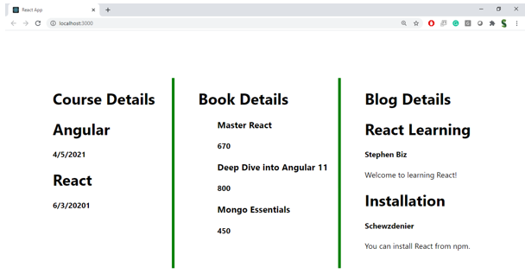

**Hint:**

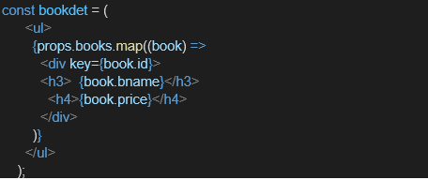

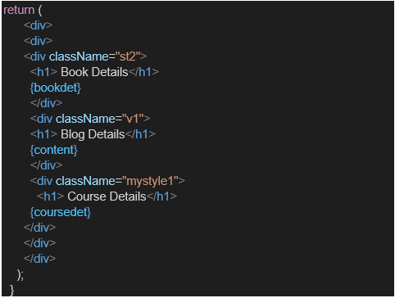

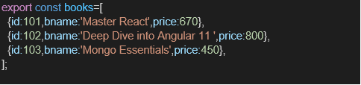

**SOURCE CODE**

**File: BookDetails.js**

import React from 'react';

function BookDetails(props) {

return (

<div className="st2">

<h1>Book Details</h1>

<ul>

{props.books.map((book) => (

<div key={book.id}>

<h3>{book.bname}</h3>

<h4>{book.price}</h4>

</div>

))}

</ul>

</div>

);

}

export default BookDetails;

**File: BlogDetails.js**

import React from 'react';

function BlogDetails(props) {

return (

<div className="v1">

<h1>Blog Details</h1>

<ul>

{props.blogs.map((blog) => (

<div key={blog.id}>

<h3>{blog.title}</h3>

<p>{blog.content}</p>

</div>

))}

</ul>

</div>

);

}

export default BlogDetails;

**File: CourseDetails.js**

import React from 'react';

function CourseDetails(props) {

return (

<div className="mystyle1">

<h1>Course Details</h1>

<ul>

{props.courses.map((course) => (

<div key={course.id}>

<h3>{course.title}</h3>

<p>Instructor: {course.instructor}</p>

</div>

))}

</ul>

</div>

);

}

export default CourseDetails;

**File: App.js**

import React from 'react';

import BookDetails from './Components/BookDetails';

import BlogDetails from './Components/BlogDetails';

import CourseDetails from './Components/CourseDetails';

// Sample Data

const books = [

{ id: 101, bname: 'Master React', price: 670 },

{ id: 102, bname: 'Deep Dive into Angular 11', price: 800 },

{ id: 103, bname: 'Mongo Essentials', price: 450 },

];

const blogs = [

{ id: 1, title: 'React Basics', content: 'Understanding React basics for beginners.' },

{ id: 2, title: 'Advanced React', content: 'Master React hooks and context API.' },

];

const courses = [

{ id: 1, title: 'React for Beginners', instructor: 'John Doe' },

{ id: 2, title: 'Advanced React', instructor: 'Jane Smith' },

];

function App() {

return (

<div className="App">

<h1 style={styles.heading}>Blogger App</h1>

<div style={styles.table}>

<div style={styles.column}>

<BookDetails books={books} />

</div>

<div style={styles.column}>

<BlogDetails blogs={blogs} />

</div>

<div style={styles.column}>

<CourseDetails courses={courses} />

</div>

</div>

</div>

);

}

export default App;

const styles = {

heading: {

textAlign: 'center',

fontSize: '28px',

marginBottom: '20px',

fontWeight: 'bold',

},

table: {

display: 'flex',

justifyContent: 'space-around',

border: '2px solid green',

padding: '20px',

borderRadius: '10px',

},

column: {

flex: 1,

padding: '10px',

margin: '0 10px',

borderLeft: '5px solid green',

borderRight: '5px solid green',

textAlign: 'center',

},

};

**OUTPUT:**

